Contents

Software design patterns 2

UML diagrams Guide 3

A- Creation design patterns 11

1. Singleton design pattern 11

2. Prototype design pattern 11

3. Builder design pattern 13

4. Factory design pattern 13

5. Abstract Factory design pattern 14

B- Structural design patterns 15

1- Proxy 15

2- Decorator 17

3- Adapter pattern 18

4- Façade pattern 19

5- Flyweight 20

6- Bridge 20

7- Composite 22

C- behaviour design patterns 23

1- Visitor 23

2- Observer 26

3- Strategy 29

4- Template Method 30

# Software design patterns

Software design patterns:General solutions to software design problems.

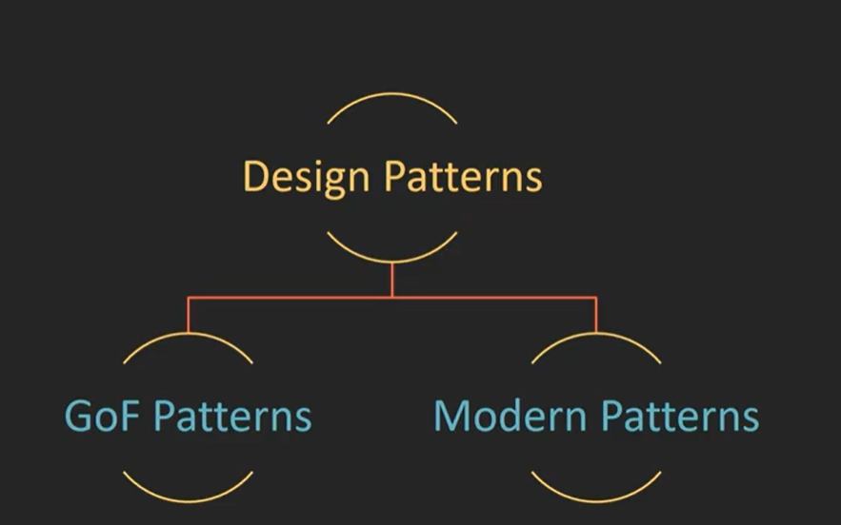

GOF design pattern categories

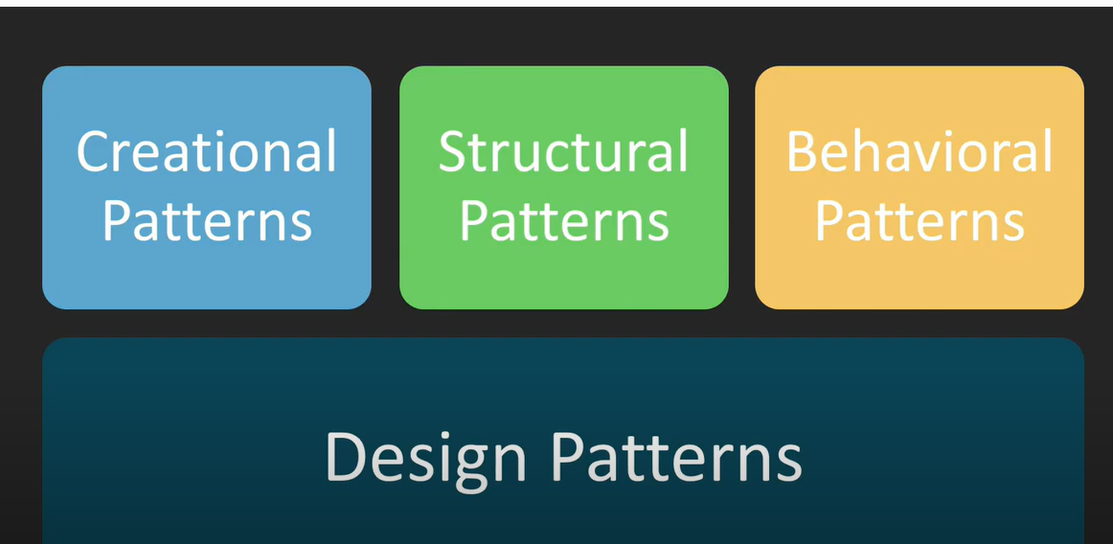

## UML diagrams Guide

Class notation



**Class Name:**

The name of the class appears in the first partition.

**Class Attributes:**

Attributes are shown in the second partition.

The attribute type is shown after the colon.

Attributes map onto member variables (data members) in code.

**Class Operations (Methods):**

Operations are shown in the third partition. They are services the class provides.

The return type of a method is shown after the colon at the end of the method signature.

The return type of method parameters are shown after the colon following the parameter name. Operations map onto class methods in code



+ denotes public

- denotes private

# denotes protected

Parameter Directionality

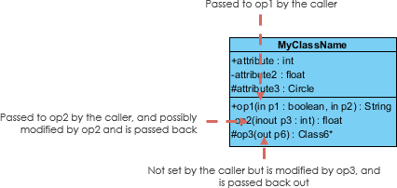

in,**out** or **inout** which specifies its direction with respect to the caller. This directionality is shown before the parameter name.

Perspectives of Class Diagram

* **Conceptual**: represents the concepts in the domain
* **Specification**: focus is on the interfaces of Abstract Data Type (ADTs) in the software
* **Implementation**: describes how classes will implement their interfaces

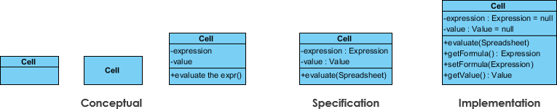

Relationships between classes

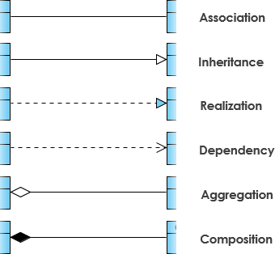

1. Inheritance (or Generalization):

* Represents an "is-a" relationship.
* An abstract class name is shown in italics.
* SubClass1 and SubClass2 are specializations of SuperClass.

The relationship is displayed as a solid line with a hollow arrowhead that points from the child element to the parent element.



**Inheritance Example - Shapes**

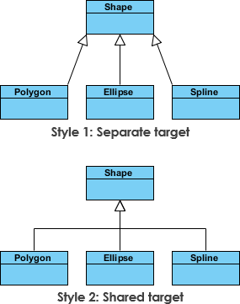

1. Association

represented by a solid line between classes.

Associations are typically named using a verb or verb phrase which reflects the real-world problem domain

Simple Association

* A structural link between two peer classes.
* There is an association between Class1 and Class2

two classes.



Cardinality

Cardinality is expressed in terms of:

* one to one
* one to many
* many to many



1. Aggregation("part of")

A special type of association.

* It represents a **"part of"** relationship.
* Many instances (denoted by the *) of Class2 can be associated with Class1.
* Objects of Class1 and Class2 have separate lifetimes.

The relationship is displayed as a solid line with a unfilled diamond at the association end, which is connected to the class that represents the aggregate.

**Class2 is part of Class1.**



1. Composition

* **A special type of aggregation where parts are destroyed when the whole is destroyed.**
* **Objects of Class2 live and die with Class1.**
* **Class2 cannot stand by itself.**

The figure below shows an example of composition. The relationship is displayed as a solid line with a filled diamond at the association end, which is connected to the class that represents the whole or composite.



1. Dependency

An object of one class might use an object of another class in the code of a method. If the object is not stored in any field, then this is modeled as a dependency relationship.

* A special type of association.
* Exists between two classes if changes to the definition of one may cause changes to the other (but not the other way around).
* **Class1 depends on Class2**

The figure below shows an example of dependency. The relationship is displayed as a dashed line with an open arrow.

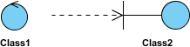

The figure below shows another example of dependency. The Person class might have a hasRead method with a Book parameter that returns true if the person has read the book (perhaps by checking some database).



1. Realization

Realization is a relationship between the blueprint class and the object containing its respective implementation level details.

This object is said to realize the blueprint class. In other words, you can understand this **as the relationship between the interface and the implementing class.**

For example, the Owner interface might specify methods for acquiring property and disposing of property. The Person and Corporation classes need to implement these methods, possibly in very different ways.

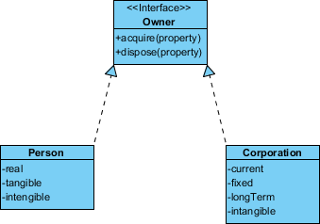

**Class Diagram Example: Order System**



**Class Diagram Example: GUI**

A class diagram may also have notes attached to classes or relationships.

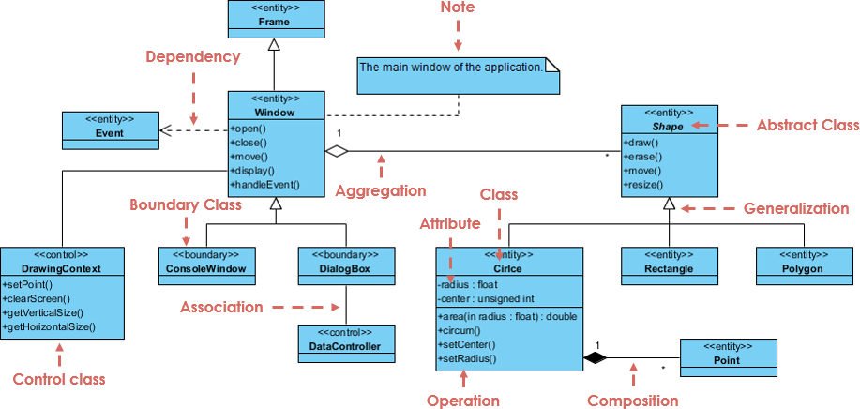

# Creation design patterns

## Singleton design pattern

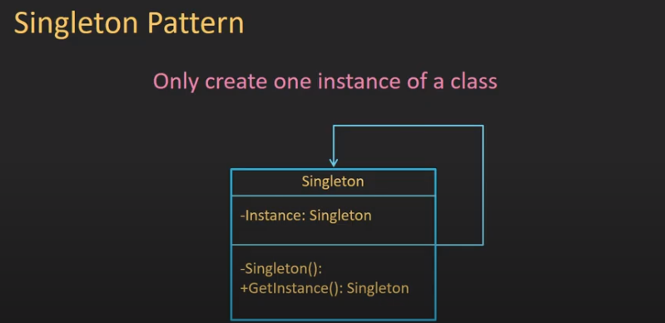

* Implementation
* Lazy initialize implementation (initialize singleton only on create obj)

## Prototype design pattern

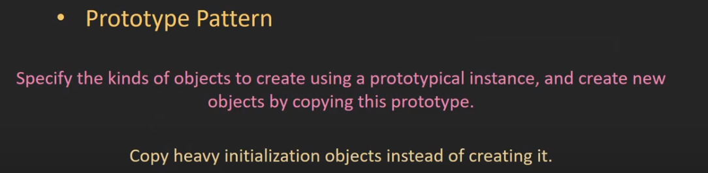

Class diagram

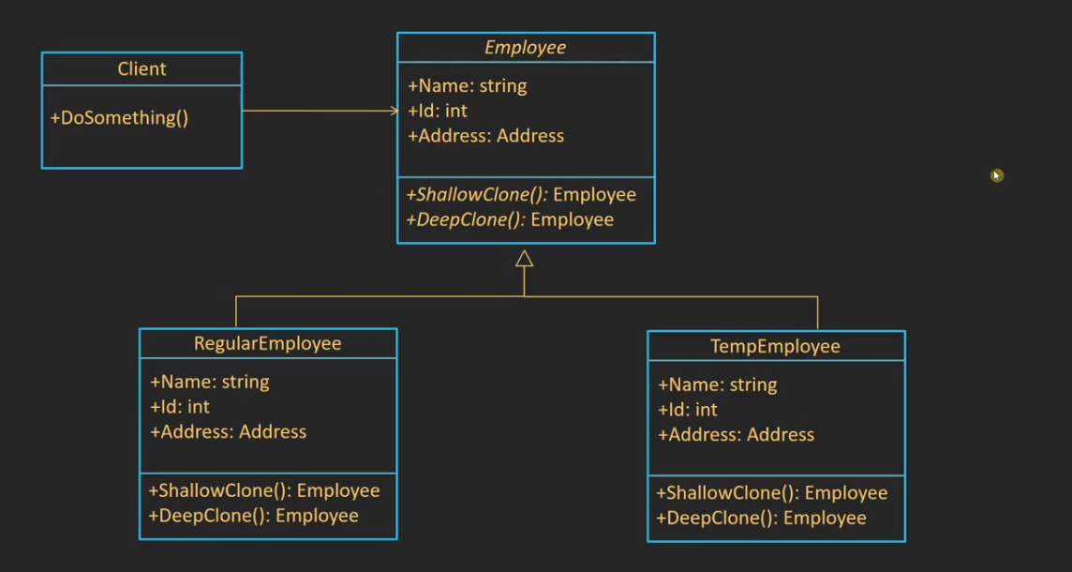

Shallow copy vs deep copy

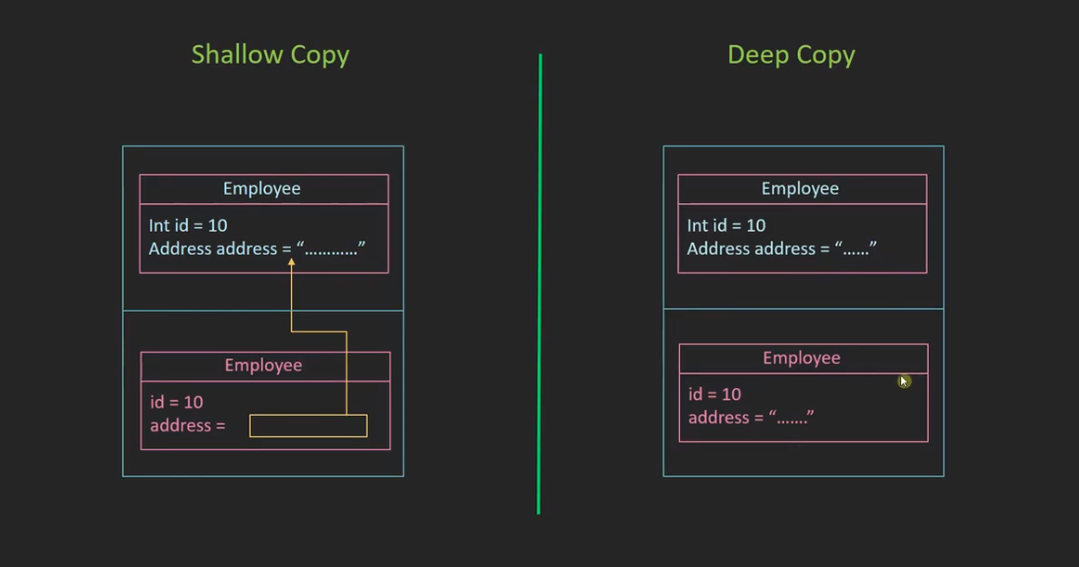

## Builder design pattern

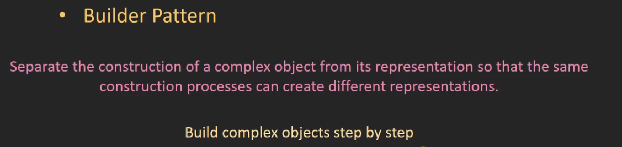

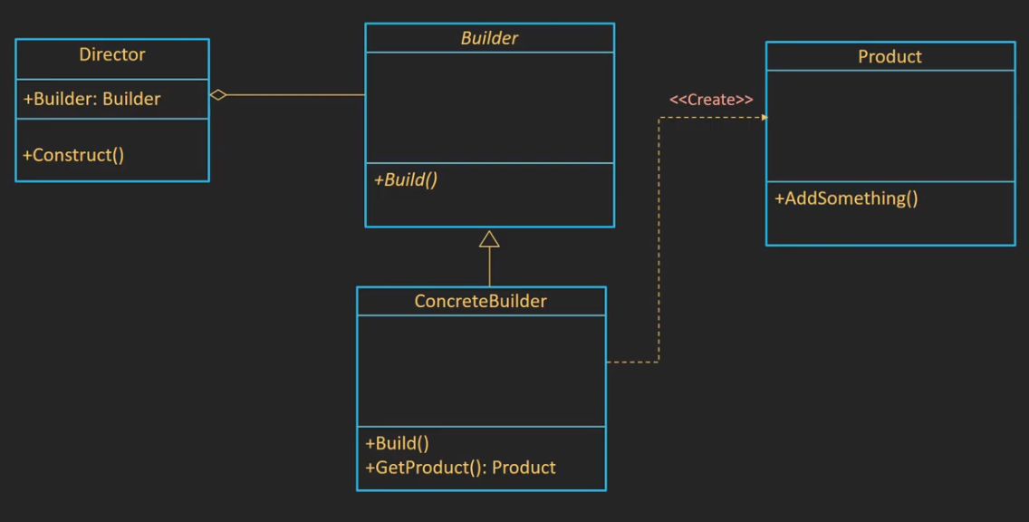

## Factory design pattern

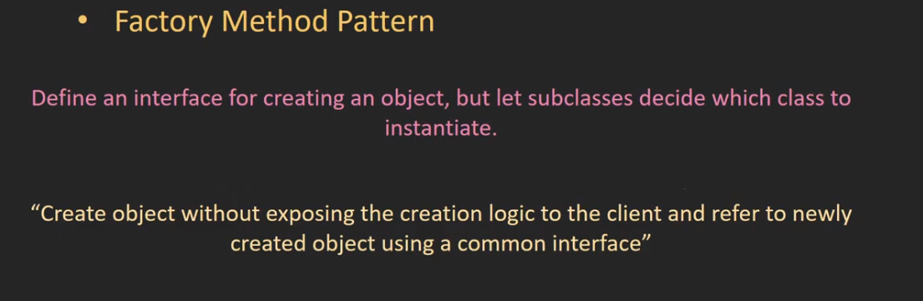

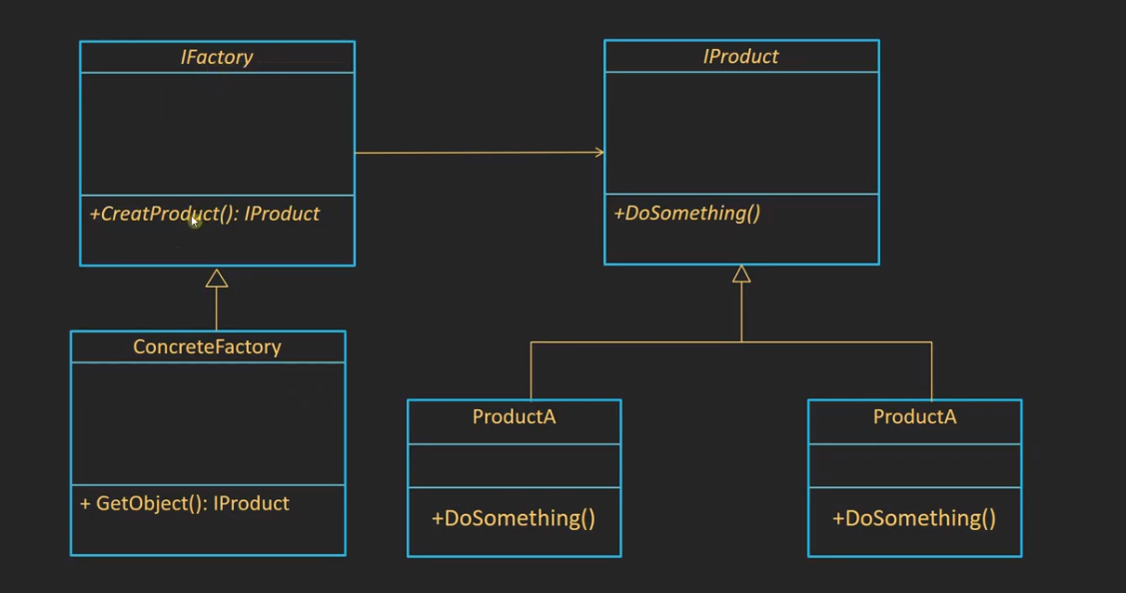

EX

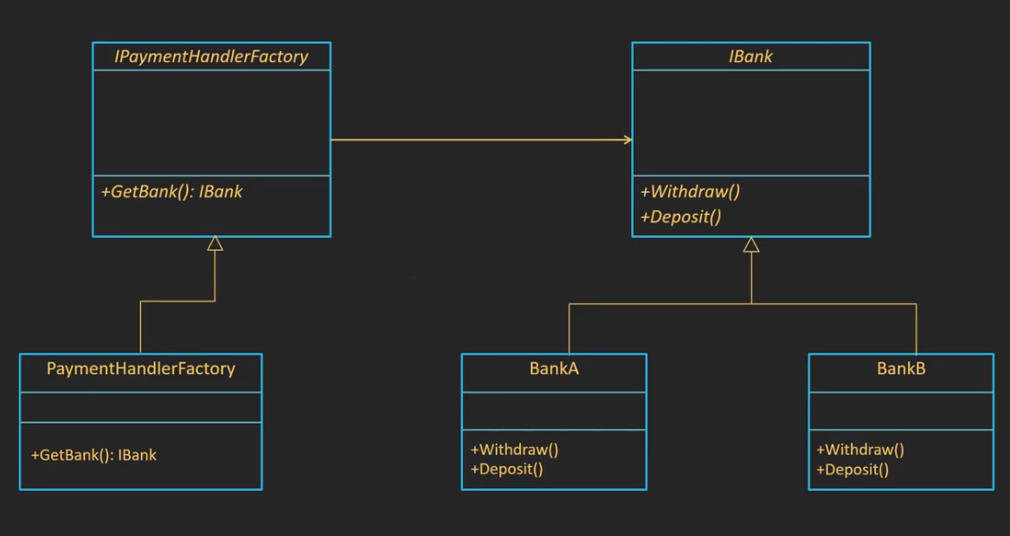

## Abstract Factory design pattern

The factory can create more than interface of obj

# Structural design patterns

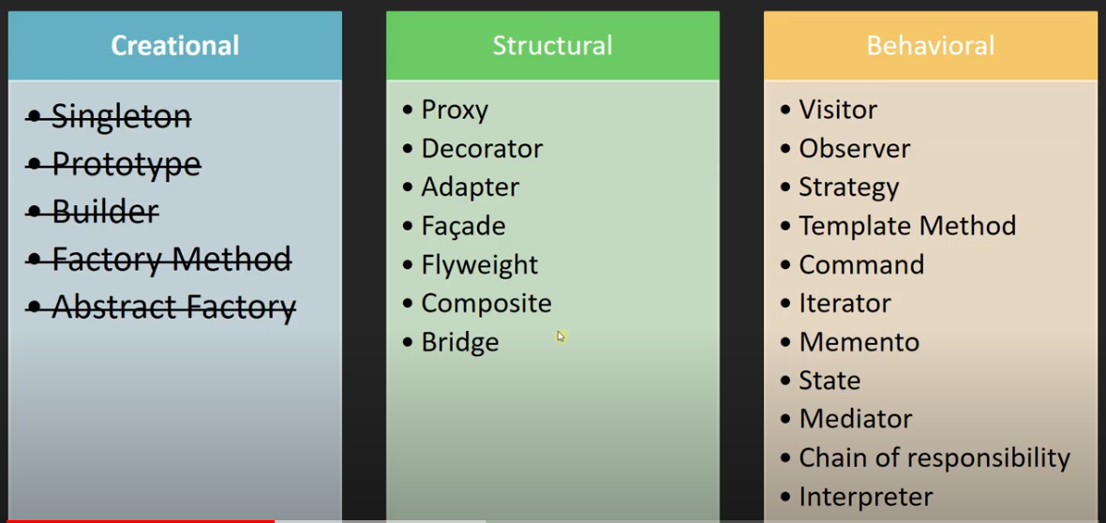

## Proxy

Control access of object

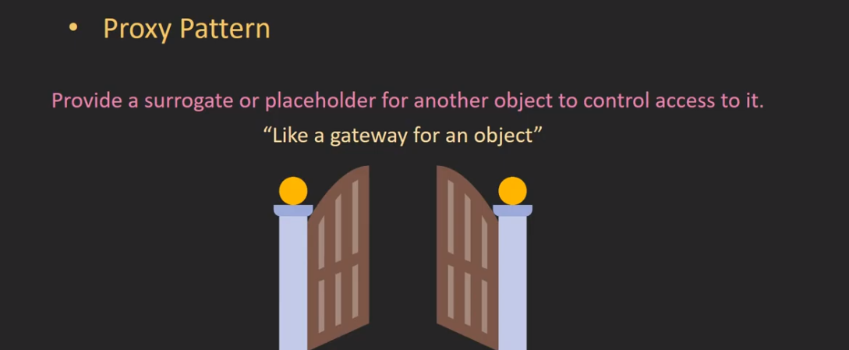

UML

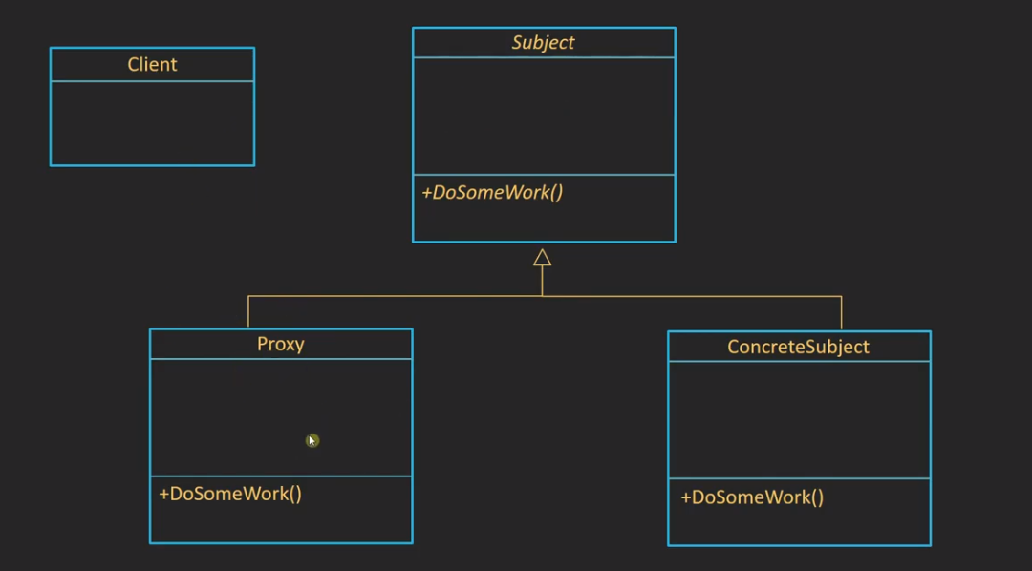

Proxy types

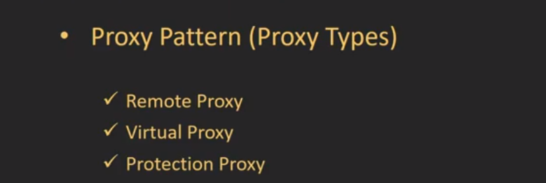

1. **Virtual Proxy:** A virtual proxy is a placeholder for “expensive to create” objects. The real object is only created when a client first requests or accesses the object.
2. **Remote Proxy:** A remote proxy provides local representation for an object that resides in a different address space.
3. **Protection Proxy:** A protection proxy control access to a sensitive master object. The surrogate object checks that the caller has the access permissions required prior to forwarding the request.

## Decorator

Attach additional responsibilities to an object dynamically. Decorators provide a

flexible alternative to subclassing for extending functionality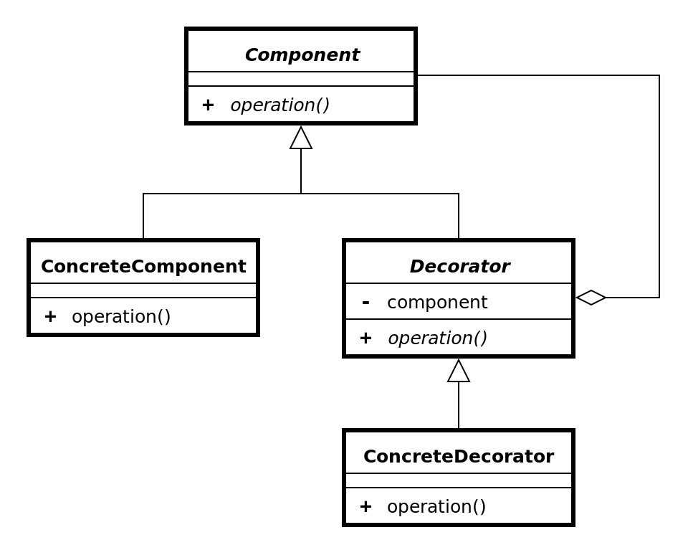



## Adapter pattern

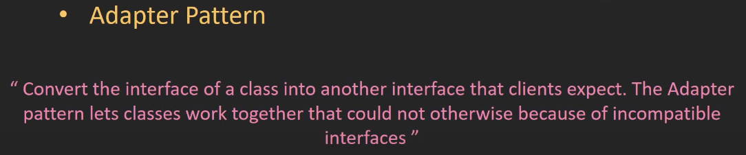

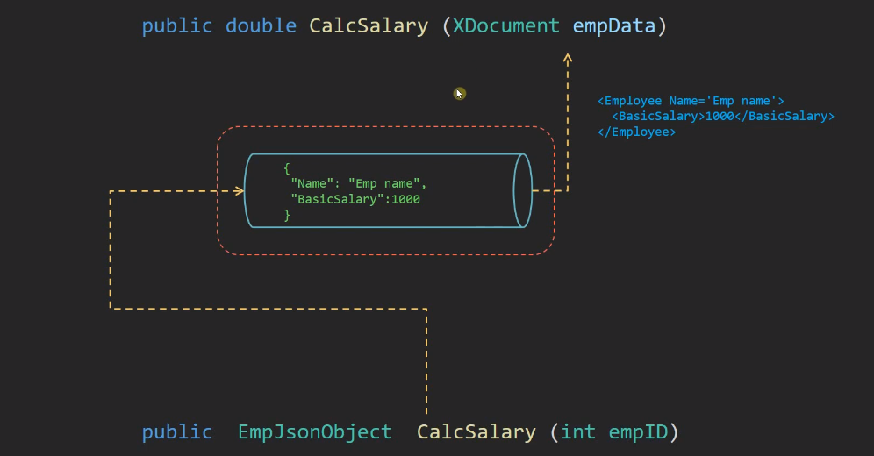



## Façade pattern



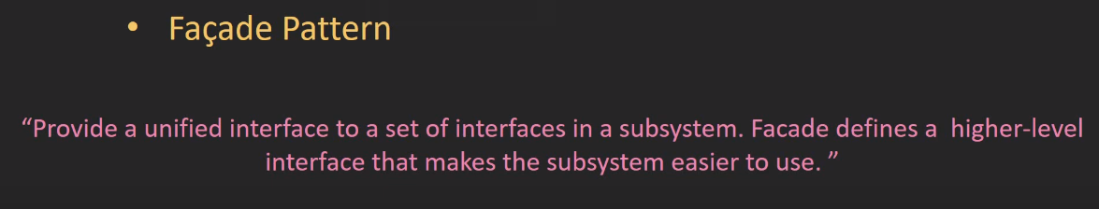

* It does not conflict with single responsibility (SOLID) because the façade class only response to collect process in one class.
* Façade vs proxy

Proxy hide or protect its inner method but façade only collect group of method

Proxy can change the behavior of process

## Flyweight

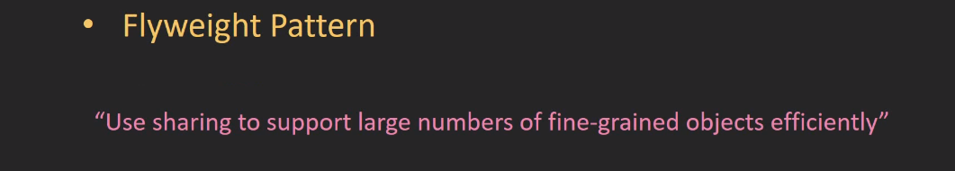

Can use with factory pattern

## Bridge

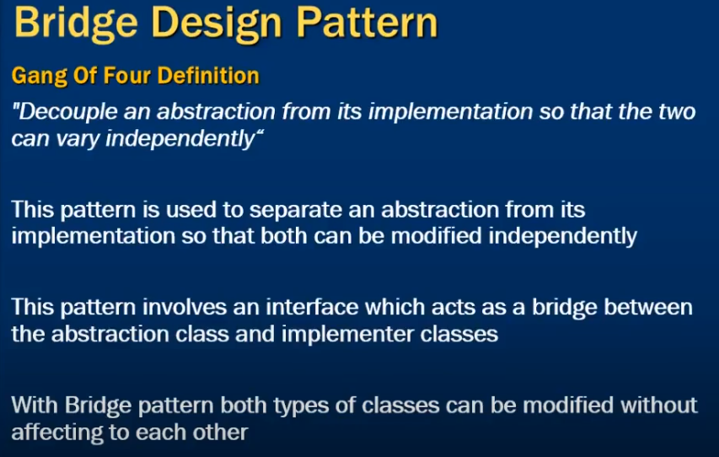

This pattern is also known as the Handle/Body pattern. With it, you decouple an

implementation class from an abstract class by providing a bridge between them.



*A classical Bridge pattern*

Implementation



## Composite

**GoF Definition**

**Compose objects into tree structures to represent part-whole hierarchies. Composite lets clients treat individual objects and compositions of objects uniformly.**

This pattern is useful to represent part-whole hierarchies of objects. In object-oriented

programming, a composite is an object with a composition of one or more similar

objects, where each of these objects has similar functionality. (This is also known as a

“has-a” relationship among objects.) So, the usage of this pattern is common in tree-structured

data.

goals with this pattern:

• You can compose objects into a tree structure to represent a part-whole

hierarchy.

• You can access both the composite objects (branches) and the

individual objects (leaf nodes) uniformly.

Ex





# behaviour design patterns

## Visitor

**GoF Definition**

Represent an operation to be performed on the elements of an object structure. Visitor

lets you define a new operation without changing the classes of the elements on which it operates.

**Concept**

With this pattern, you separate an algorithm from an object structure.

So, you can add new operations without modifying the existing architecture.

This pattern supports the open/close principle (which says extension is allowed but modification is disallowed for entities such as class, function, modules, and so on).





Visitor with composite

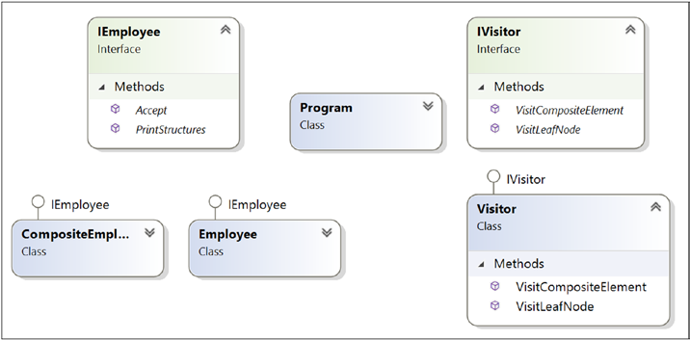

## Observer

***GoF Definition***

Define a one-to-many dependency between objects so that when one object changes state, all its dependents are notified and updated automatically.

Concept

In this pattern, there are many observers (objects) that are observing a particular subject

(also, an object). Observers want to be notified when there is a change made inside

the subject. So, they register themselves to that subject. When they lose interest in the subject, they simply unregister from the subject. Sometimes this model is referred as the Publisher-Subscriber model. The whole idea can be summarized as follows: using this pattern, an object (subject) can send notifications to multiple observers (a set of objects) at the same time.



Registered



Notification



Observer 2 unsubscribe itself





## Strategy

GoF Definition

Define a family of algorithms, encapsulate each one, and make them interchangeable.

Strategy lets the algorithm vary independently from clients that use it..

Concept

You can select the behavior of an algorithm dynamically at runtime.





## Template Method

**GoF Definition**

define the skeleton of an algorithm in an operation, deferring some steps to subclasses.

The Template Method pattern lets subclasses redefine certain steps of an algorithm without changing the algorithm’s structure

Concept

With the Template Method pattern, you define the minimum or essential structure of an

algorithm. Then you defer some responsibility to the subclasses. The key idea is that you

can redefine certain steps of an algorithm, but those changes will not impact the core

architecture.

This design pattern is useful if you have to implement a multistep algorithm and you

want to allow customization through subclasses.



**What are the key advantages of using a Template Method design pattern?**

Answer:

• You can control the flow of the algorithms. Clients cannot

change them.

• Common operations will be in a centralized location. For

example, in an abstract class, the subclasses can redefine only the

varying parts so that you can avoid redundant code.

**6. What are the key challenges associated with a Template Method design pattern?**

Answer:

• The client code cannot direct the sequence of steps. If you want

that type of functionality, use the Builder pattern.

• A subclass can override a method defined in the parent class

(in other words, hiding the original definition in the parent class),

which can go against the Liskov substitution principle that

basically says that if S is a subtype of T, then objects of type T

can be replaced with objects of type S. You can learn more here:

https://en.wikipedia.org/wiki/Liskov_substitution_

principle.

• Having more subclasses means more scattered code, which is

difficult to maintain.

## Command

GoF Definition

Encapsulate a request as an object, thereby letting you parameterize clients with

different requests, queue or log requests, and support undoable operations.

Concept

With this pattern, you encapsulate a method invocation process. In general, four terms

are important here: *invoker*, *client*, *command*, and *receiver*. A *command* object can

invoke a method of the receiver in a way that is specific to that receiver’s class. The

*receiver* then starts processing the job. A command object is separately passed to the

*invoker* object to invoke the command. The *client* object holds the invoker object and

the command objects. The client only makes the decision (which commands to execute)

and then passes the command to the invoker object (for the execution).



